Database creation:
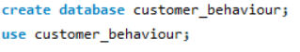

- What is the total revenue generated by male vs. female customers?
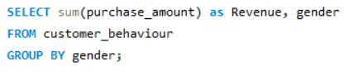
Output:
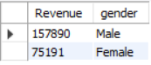
- Which customers used a discount but still spent more than the average purchase amount?
Output:
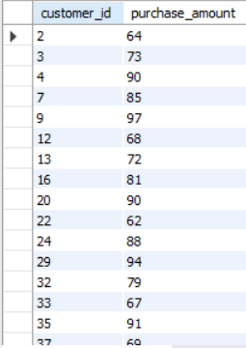
- Which are the top 5 products with the highest average review rating?
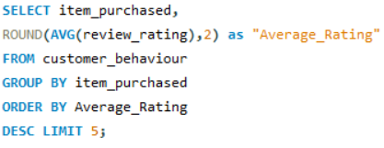
Output:
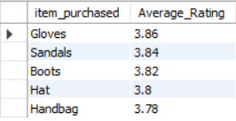
- Compare the average Purchase Amounts between Standard and Express Shipping.
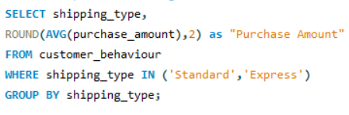
Output:
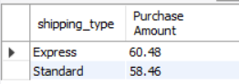
- Do subscribed customers spend more? Compare average spend and total revenue between subscribers and non-subscribers.
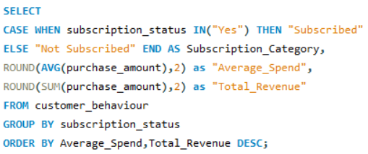
Output:
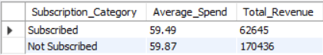
- Which 5 products have the highest percentage of purchases with discounts applied?
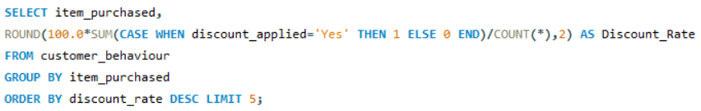
Output:
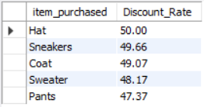
- Segment customers into New, Returning, and Loyal based on their total number of previous purchases, and show the count of each segment.
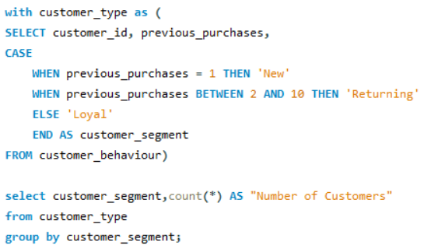
Output:
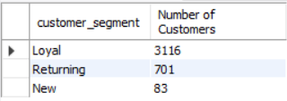
- What are the top 3 most purchased products within each category?
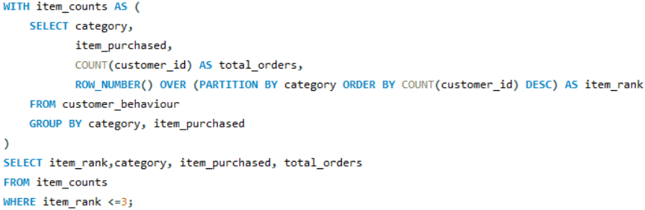
Output:
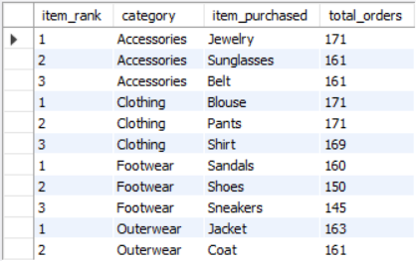
- Are customers who are repeat buyers (more than 5 previous purchases) also likely to subscribe?
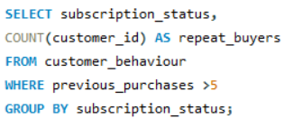
Output:
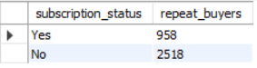
- What is the revenue contribution of each age group?
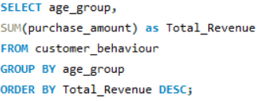
Output:
